ATTACHMENT A • SCOPE OF SERVICES

TABLE OF CONTENTS

ARTICLE AI • INTRODUCTION 1

A. DESCRIPTION 1

B. LOCATION 1

C. COORDINATION 1

D. STANDARDS 1

E. QUALITY CONTROL 4

F. KEY PERSONNEL 5

G. COUNTY RESPONSIBILITIES 5

ARTICLE AII • CONTRACT ADMINISTRATION 6

A. CONTRACT MANAGEMENT 6

B. COST ACCOUNTING 6

C. SCHEDULING 6

ARTICLE AIII • SERVICES TO BE PROVIDED/SCOPE OF WORK 6

A. LAND SURVEYING TASKS 6

ARTICLE AI • INTRODUCTION

A. DESCRIPTION

Services provided under this contract will be performed on an on-call basis to the Riverside County Transportation Department for land surveying related WORK ASSIGNMENTS located throughout Riverside County.

B. LOCATION

On-call Task Orders may be located anywhere within the jurisdictional boundaries of the County of Riverside as outlined in the map shown below.

**Map of the County of Riverside**

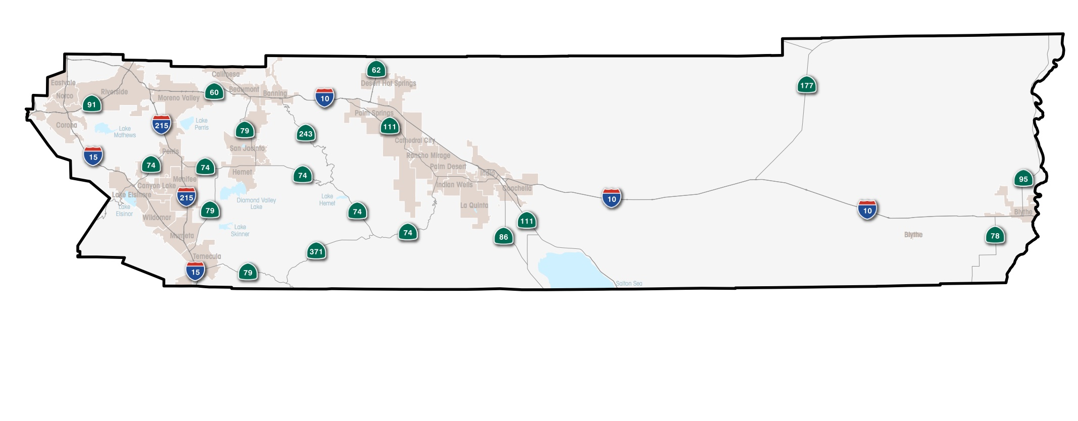

C. COORDINATION

SURVEYOR may be required to coordinate with other involved agencies. Coordination may include, but will not necessarily be limited to the following:

• Relevant Cities • Caltrans

• Utility Companies • Federal Agencies

All meetings with outside agencies will be scheduled by SURVEYOR with approval of COUNTY.

D. STANDARDS

All work will be prepared in accordance with COUNTY and/or Caltrans practices, regulations, policies, procedures, manuals, and standards or as directed. Deliverables will be prepared in accordance with the most current Caltrans guidance. Exceptions must be approved by COUNTY in advance.

**1. Geographical Information System (GIS)**

a. "GIS Information" shall include GIS digital files (including the information or data contained therein) and any other information, data, or documentation from COUNTY GIS (regardless of medium or format) that is provided pursuant to this Agreement.

b. SURVEYOR acknowledges that the unauthorized use, transfer, assignment, sublicensing, or disclosure of the GIS information, documentation, or copies thereof will substantially diminish their value to COUNTY. SURVEYOR acknowledges and agrees that COUNTY GIS information is a valuable proprietary product, embodying substantial creative efforts, trade secrets, and confidential information and ideas. COUNTY GIS information is and shall remain the sole property of COUNTY; and there is no intention of COUNTY to transfer ownership of COUNTY GIS information.

c. COUNTY GIS information is made available to SURVEYOR solely for use in the normal course of SURVEYOR business to produce reports, analysis, maps and other deliverables only for a specific PROJECT and as described within the Scope of Services.

d. SURVEYOR agrees to indemnify and hold harmless COUNTY, its officers, employees and agents from any and all liabilities, claims, actions, losses or damages relating to or arising from SURVEYOR use of COUNTY GIS information.

e. GIS information cannot be used for all purposes; and GIS information may not be complete for all purposes. Additional investigation or research by SURVEYOR into other sources will be required. GIS information is intended only as an information base and is not intended to replace any legal records. COUNTY has used and will continue to use its best efforts to correctly input into COUNTY GIS the information contained in various legal and other records; but COUNTY accepts no responsibility for any conflict with actual legal records or for information not transferred from legal records to COUNTY GIS. COUNTY has attempted to update GIS information as often as is practically feasible. However, SURVEYOR should be aware that GIS information may not be current and changes or additions to the information contained in COUNTY GIS may not yet be reflected in COUNTY GIS.

f. COUNTY accepts no responsibility for the use of GIS information; and COUNTY provides no warranty for the use of COUNTY GIS or COUNTY GIS information by CONSULTANT. THE WARRANTIES SPECIFICALLY SET FORTH IN THIS AGREEMENT ARE IN LIEU OF ALL OTHER WARRANTIES, EXPRESS OR IMPLIED, INCLUDING THE WARRANTIES OF MERCHANTABILITY AND FITNESS FOR A PARTICULAR PURPOSE; AND SUCH OTHER WARRANTIES ARE HEREBY EXCLUDED.

g. Final plans, drawings or other work products will be provided in an electronic format suitable for inclusion within the COUNTY GIS or CADD Systems by SURVEYOR and will contain the appropriate meta data and will be geographically registered using an appropriate coordinate system such as the California State Plane Coordinate System NAD 83.

**5. Project Files**

Project files shall be indexed in accordance with CALTRANS’ Project Development Uniform File System.

E. QUALITY CONTROL

1. SURVEYOR shall implement and maintain the following quality control procedures during the preparation of the plans and documents relating to this Contract. SURVEYOR shall have a quality control plan in effect during the entire time services are being performed under this Agreement. The plan shall establish a process whereby calculations are independently checked, plans checked, corrected and back-checked, and all job related correspondence and memoranda routed and received by affected persons and then bound in appropriate job files. Where several drawings show different work in the same area, means shall be provided to avoid conflicts and misalignment in both new and existing improvements. Evidence that the quality control plan is functional may be requested by the COUNTY Contract Administrator. All plans, calculations documents and other items submitted to the COUNTY Contract Administrator for review shall be marked clearly as being fully checked and that the preparation of the material followed the quality control plan established for the work.

2. SURVEYOR has total responsibility for the accuracy and completeness of all data, reports, plans, specifications and estimates prepared for this Contract and shall check all such material accordingly. COUNTY will review all work product deliverables. The responsibility for accuracy and completeness of such items remains solely that of CONSULTANT. Neither COUNTY’S review nor approval shall give rise to any liability or responsibility on the part of COUNTY, or waive any of COUNTY’S rights, or relieve SURVEYOR of its professional responsibilities or obligations under this Agreement.

3. The plans, designs, estimates, calculations, reports and other documents furnished in accordance with the Scope of Services shall meet the criteria for acceptance and be a product of neat appearance, well organized, technically and grammatically correct, checked and having the preparer and checker identified. The minimum standard of appearance, organization and contents shall be of similar types produced by COUNTY and AGENCIES. If any work product submitted is not complete and ready for use by COUNTY, it shall be marked “Draft” or similar designation to indicate it is not ready for use by COUNTY. COUNTY expects that all work product not so designated is ready for and can be used as a final product.

4. The page identifying preparers of land surveying notes / reports, the title sheet for specifications and each sheet of plans, shall bear the professional seal, certificate number, registration classification, expiration date of the certificate, and signature of the professional land surveyors(s) responsible for their preparation.

F. KEY PERSONNEL

The SURVEYOR has represented to the COUNTY that certain key personnel will perform the services and if one or more of such personnel should become unavailable, SURVEYOR may substitute other personnel of at least equal competence only after prior written approval by the COUNTY’s Contract Administrator has been secured. The key personnel for performance of this Contract are:

**Position** **Name**

[TITLE] [NAME]

ARTICLE AII • CONTRACT ADMINISTRATION

A. CONTRACT MANAGEMENT

The SURVEYOR Contract Manager will maintain ongoing liaison with the COUNTY’s Contract Administrator and other effected agencies to promote effective coordination during the course of working on Task Orders.

B. COST ACCOUNTING

The SURVEYOR will prepare and submit monthly invoices of expenditures for each on-call Task Order. Expenditures include direct labor costs, other direct costs and sub-SURVEYOR costs. All Invoices will include all supporting data.

C. SCHEDULING

Schedules will be prepared for each specific Task Order and shall require prior approval.

ARTICLE AIII • SERVICES TO BE PROVIDED/SCOPE OF WORK

The scope of work for this contract is to provide on-call services to the Riverside County Transportation Department for transportation related services located throughout Riverside County. Services will be performed at the request of the COUNTY’s Contract Administrator. SURVEYOR and COUNTY shall negotiate and establish a cost estimate that is consistent with the services listed below and the SURVEYOR billing rates as provided in Attachment C. Each Task Order shall be memorialized in writing and approved by the Director of Transportation and by the SURVEYOR Contract Manager or authorized designees. The sum of the Task Orders cost estimates authorized in each year shall not exceed the maximum annual amount. The SURVEYOR may be required to provide on-call services that include but are not limited to the following:

**A. LAND SURVEYING TASKS**

1. Performing field surveys of control nets and lines, boundary lines, topography and existing facilities or structures. Survey procedures along with survey notes will be reviewed by the COUNTY.
2. Preparation of legal descriptions, plats, record of survey, corner records, and right-of-way maps.
3. Survey services in support of photogrammetric surveys. Coordinate with the COUNTY to set up photogrammetric surveys based on aerial diagrams provided by photogrammetrist. Also included is the setting of aerial control points, placing horizontal/vertical data for the positions, locate control as needed for alignment purposes, locate existing utilities, culverts, and other infrastructure pertinent for designing, engineering, and/or surveying projects. All data will be reviewed by the COUNTY prior to submitting product for completion.
4. Performing various types of surveying tasks on all types of construction projects.
5. Performing Quality Assurance work. SURVEYOR will be provided two sets of plans. SURVEYOR will be directed by the COUNTY for the scope of work. Generally, work will consist of: setting initial control points with horizontal and vertical values, checking various stages of construction at the direction of the onsite inspector, documenting progress including any conflicts, and other quality assurance work.
6. Reviewing, suggesting corrections, and making recommendations on the checking of parcel maps, records of survey, right-of-way cases, minor land division cases, corner records, and final subdivision maps.
7. Performing field monument inspections on parcel maps and final subdivision maps.
8. Performing volume calculations and associated field surveys.
9. Process and map Aerial Drone Data
10. Other associated professional services that may be requested.
11. All data submitted under a contract shall be processed and formatted using Bentley MicroStation in the version specified by COUNTY (currently MicroStation V8i). For all preliminary projects, the SURVEYOR will use the COUNTY data collection code table (latest version) specifically prepared for InRoads software unless directed otherwise by COUNTY.

*All plans shall be prepared and submitted using County approved versions of MicroStation V8i software.